Leipzig meeting at April 2nd, 2007

Participants:

Clare Llewellyn (part 1 + 2)
Rob Sanderson (part 1 + 2)
Mathias Manecke (part 1 + 2)
Frieder Schmidt (part 1 + 2)
Emanuel Wenger (part 2)

Minutes

1. Assignment of tasks

German National Library needs technical assistance to bring bibliographical data to the web for integration in the Bernstein workspace. The originally intended way via the library’s central server system and Z39.50 was not possible within the given time limit. An alternative way will be to subcontract an expert for the database system allegro C – actually the platform for the bibliographic records – and to get help from the Liverpool team.

2. Database Schema

After validation of some alternative models the following schema got preference:

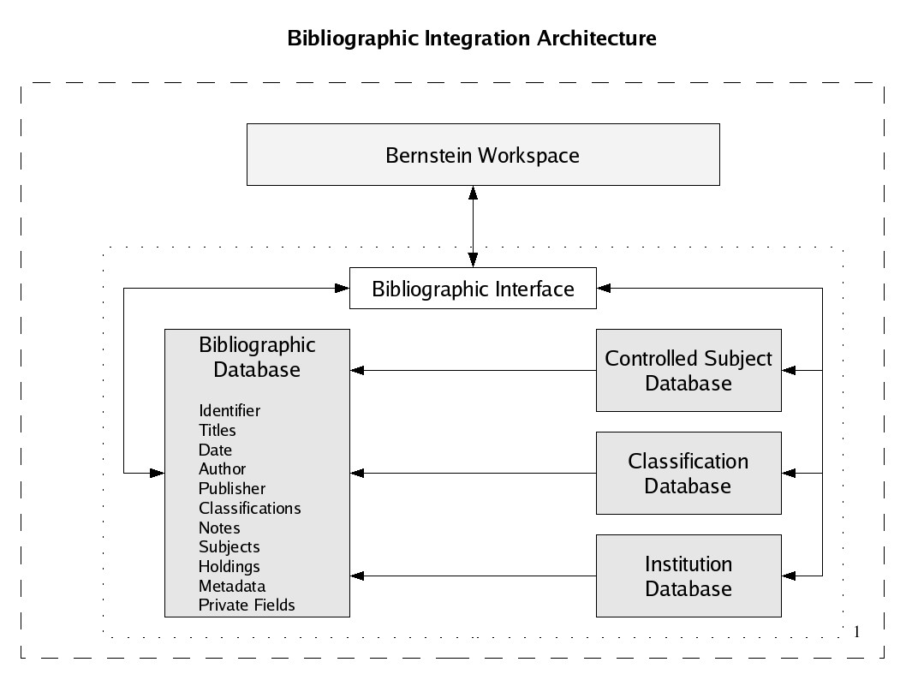
3. Tasks

DNB describes in detail the necessary steps to transform the existing allegro database in a more normalized version intending a complete data export (xml format). Therefore it asks an expert to bid for that task.

Liverpool University checks possibility of data processing if DNB will commit a parts of its budget (question of own contribution). DNB is willing to leave up to 20 percent to Liverpool University. If this resources would not be enough, Technische Universität Graz should be asked for some support, because of the intended way would be an important support for database integration.

E. Wenger in his function as a project coordinator is willing to contact the project officer, whether it is possible
a) to outsource the task described above,
b) to transfer a budget part from DNB to Liverpool University.

4. Schedule

DNB immediately starts description of the necessary tasks and asks for a bid of an expert as a subcontractor. If subcontracting is possible, it is aim to deliver to Liverpool a set of 200-300 records for test and integration purposes until middle of May 2007. In consequence Liverpool will present a first integration until July 2007.

In May 2007 conditions will also be given to the data processing necessary to realize multilingual access to the bibliographic records.

5. Conclusion

Assumed affirmation of all participants the described way will give DNB a second chance to deliver the first milestone just in time.

